Discussions Wk6D

Part I
Explain the relationship among disk platters, tracks, sectors, and clusters.

A disk platter is a circular disk storage device that is divided into tracks, sectors, and clusters such as a hard drive. A track is a single circular line of sectors. A sector is a subdivision of a track and stores a fixed amount of data. It is the smallest unit of storage on a disk platter. A cluster is a logically contiguous group of sectors. It is the smallest unit of storage for files and directories.

Here is a diagram that demonstrates the relationship between the terms:
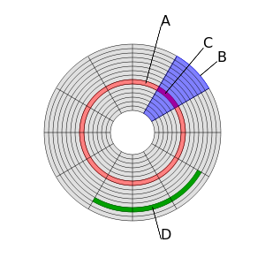

Part II

Given the following sequence of events (Interrupt requests IRQi), show which services routines the CPU is executing for times 0 to 100 ms. Consider that each IRQi- Interrupt service routine takes 15 ms to complete.
Time Action
0 ms Start of main program
10 ms IRQ3 Interrupt request 3 is coming
20 ms IRQ2 Interrupt request 2 is coming
45 ms IRQ1 Interrupt request 1 is coming
60 ms IRQ0 Interrupt request 0 is coming

IRQ n has the lowest priority; IRQ 0 has the highest priority
Obs:
If IRQi is coming in the period of execution of IRQj and j has higher priority, then IRQi is postponed until IRQj is finished.
If IRQi is coming in the period of execution of IRQj and i has higher priority, then IRQi is started and IRQj is temporally suspended until IRQi is finished.

Time Action

0ms: Start of Main Program
10ms: IRQ3 started
20ms: IRQ2 started, IRQ3 pending 5ms
35ms: IRQ2 completed, IRQ3 pending 5ms
40ms: IRQ3 completed
45ms: IRQ1 started
60ms: IRQ0 started, IRQ1 completed
75ms: IRQ0 completed
100ms End of Main Program

Summary:

Time Action

0-10ms Main (Start)
10-20ms IRQ3
20-35ms IRQ2
35-40ms IRQ3
40-45ms Main
45-60ms IRQ1
60-75ms IRQ0
75-100ms Main (End)

Time
5
10
15
20
25
30
35
40
45
50
55
60
65
70
75
80
85
90
95
100
CPU Execution
IRQ3

relationship between the terms;tes the relationship between the teracks, sectors, and clusters.
IRQ0
IRQ1
IRQ2
IRQ3
MAIN
MAIN
IRQ3
IRQ1
IRQ0
IRQ2
MAIN

Indication:
Please see here a similar example considering each IRQ service routines takes 20 ms to complete.

Given the following sequence of events (Interrupt requests IRQi), show which services routines the CPU is executing for times 0 to 100 ms. Consider that each IRQi- Interrupt service routine takes 20 ms to complete.
Time Action
0 ms Start of main program
10 ms IRQ3 Interrupt request 3 is coming
20 ms IRQ2 Interrupt request 2 is coming
45 ms IRQ1 Interrupt request 1 is coming
60 ms IRQ0 Interrupt request 0 is coming

IRQ n has the lowest priority; IRQ 0 has the highest priority
Obs:
If IRQi is coming in the period of execution of IRQj and j has higher priority, then IRQi is postponed until IRQj is finished.
If IRQi is coming in the period of execution of IRQj and i has higher priority, then IRQi is started and IRQj is temporally suspended until IRQi is finished.

The solution for 20 ms is:

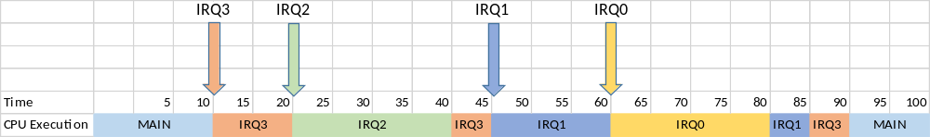

More details is presented in the following figure:

